Eyeconic - Glasses Shop Management System

Edit Storage Boxes

Version <1.0>

Revision History

|  |  |  |  |
| --- | --- | --- | --- |
| **Date** | **Version** | **Description** | **Author** |
| <05/11/2019> | <1.0> | Start creating use case | Nguyễn Tuấn Anh |
|  |  |  |  |

Table of Contents

1. Edit Storage Boxes 4

1.1 Brief Description 4

1.2 Basic Flow 4

2.2 Exception 5

2.2.1 Edit Storage Boxes 5

2.2.2 Fill in the Storage Boxes information 5

2. Special Requirements 5

3. Preconditions 5

4. Postconditions 5

5. Extension Points 5

Use-Case Specification: Edit Storage Boxes

# Edit Storage Boxes

## Brief Description

This use case defines the step of update existing Storage Boxes

Storage Boxes are updated by the admin.

## Basic Flow

The system administration selects the Storage Boxes data to edit. The administrator changes the information. The system displays the updated management parameter value and logs the change

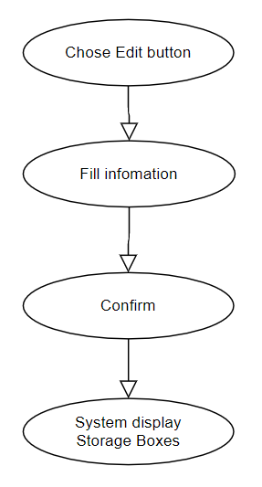

***Basic flow of Editing Storage Boxes***

Step 1: Choose the Storage Boxes you want to edit

Step 2: Click edit button

A modal view shows up

Edit the information.

Step 3: Confirming editing the Storage Boxes by clicking the “Save” button.

Step 4: Successful information changed Storage Boxes are displayed on the screen

## 2.2 Exception

### 2.2.1 Edit Storage Boxes

The edit button cannot be clicked or isn’t appeared on the screen

### 2.2.2 Fill in the Storage Boxes information

Invalid information.

2.2.3 Confirming editing the Storage Box

The “Save” button is clicked but the new information of the Storage Boxes are not changed.

2.2.4 System displays edited Storage Box

The edited Storage Boxes’ information are not display correctly.

# Special Requirements

# Preconditions

User must already login as the administrator of the website.

# Postconditions

Storage Boxes information is changed and can be purchased by customers.

# Extension Points

Administrator check the website and the system to ensure that the edited information of the Storage Boxes is correct.